LLM

A large language model (LLM) is a neural network trained on a vast amount of text for natural language processing tasks, especially language generation. LLMs can generate, summarize, translate and parse text in many contexts, and are a foundational technology behind modern chatbots. Biased or inaccurate training data can make an LLM's output less reliable.
An LLM is a machine learning model trained on huge amounts of text (books, websites, conversations, etc.). Its goal is to learn patterns in language—like grammar, meaning, and context.
At their core, Large Language Models (LLMs) are highly advanced statistical calculators designed to predict the next most likely word (or part of a word, called a token) in a sequence.

LLMs are generally based on the transformer architecture, which leverages an attention mechanism that enables the model to process relationships between all elements in a sequence simultaneously, regardless of their distance from each other.

Despite sophisticated architectures and massive scale, large language models exhibit persistent and well-documented limitations that constrain their deployment in high-stakes applications.
- Hallucinations
- is a response generated by AI that contains false or misleading information presented as fact.
- Algorithmic bias
systematic and repeatable harmful tendency in a computerized sociotechnical system to create "unfair" outcomes, such as "privileging" one category over another in ways that may or may not be different from the intended function of the algorithm
Types
- Stereotyping - AI models can reinforce a wide range of stereotypes due to generalization, including those based on gender, ethnicity, age, nationality, religion, or occupation
- Selection bias refers the inherent tendency of large language models to favor certain option identifiers irrespective of the actual content of the options.
- Political bias refers to the tendency of algorithms to systematically favor certain political viewpoints, ideologies, or outcomes over others.

WORKING OF LLM
LLMs are primarily based on the Transformer architecture which enables them to learn long range dependencies and contextual meaning in text.

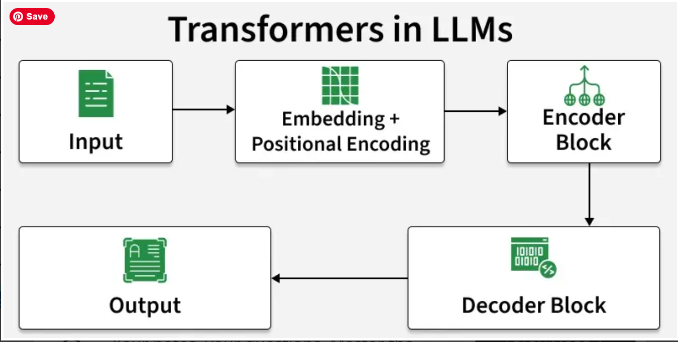

A key factor in how LLMs work is the way they represent words. Earlier forms of machine learning used a numerical table to represent each word. But, this form of representation could not recognize relationships between words such as words with similar meanings. This limitation was overcome by using multi-dimensional vectors, commonly referred to as word embeddings, to represent words so that words with similar contextual meanings or other relationships are close to each other in the vector space.
Using word embeddings, transformers can pre-process text as numerical representations through the encoder and understand the context of words and phrases with similar meanings as well as other relationships between words such as parts of speech. It is then possible for LLMs to apply this knowledge of the language through the decoder to produce a unique output.

APPLICATIONS
- Code Generation: LLMs can generate accurate code based on user instructions for specific tasks.
- Debugging and Documentation: They assist in identifying code errors, suggesting fixes and even automating project documentation.
- Question Answering: Users can ask both casual and complex questions, receiving detailed, context-aware responses.
- Language Translation and Correction: LLMs can translate across many languages (often dozens to 100+).
- Prompt-Based Versatility: By crafting creative prompts, users can unlock endless possibilities, as LLMs excel in one-shot and zero-shot learning scenarios.

Popular AI Models -
- Gemini by Google
- GPT-4 by OpenAI
- Claude by Anthropic
- Llama by Meta

RAG
RAG (Retrieval-Augmented Generation) is an AI framework that grounds Large Language Models (LLMs) in external data. Instead of relying solely on fixed training data, RAG retrieves relevant information from a custom knowledge base (like company documents) before generating a response, drastically reducing errors and "hallucinations".
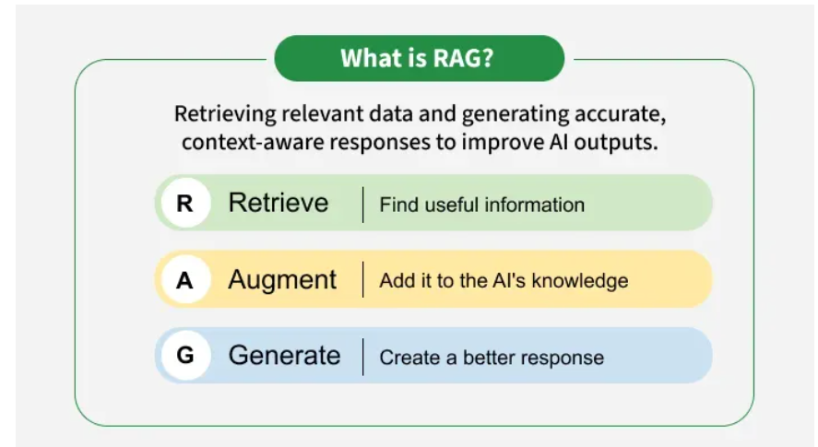
Retrieval Augmented Generation (RAG) is a technique that enhances LLMs by integrating them with external data sources. By combining the generative capabilities of models like GPT-4 with precise information retrieval mechanisms, RAG enables AI systems to produce more accurate and contextually relevant responses.
LLMs are powerful but come with inherent limitations:
- Limited knowledge: LLMs can only generate responses based on their training data, which may be outdated or lack domain-specific information.
- Hallucinations: These models sometimes generate plausible-sounding but incorrect information.
- Generic responses: Without access to external sources, LLMs may provide vague or imprecise answers.
RAG addresses these issues by allowing models to retrieve up-to-date and domain-specific information from structured and unstructured data sources, such as databases, documentation, and APIs.

WORKING
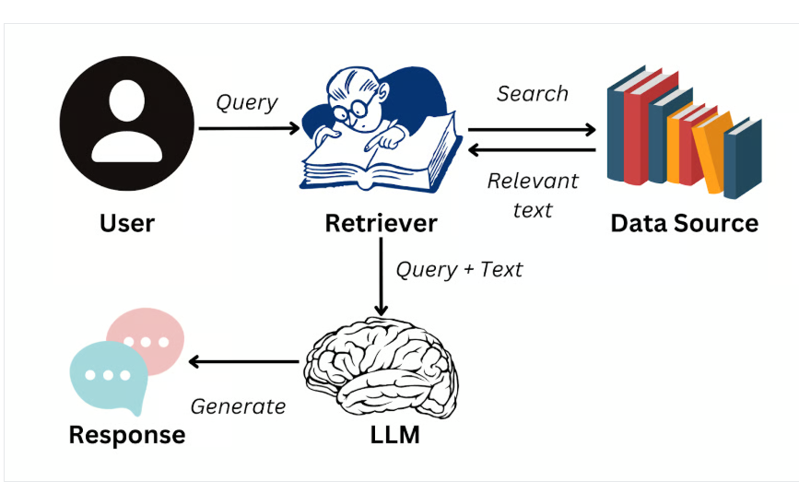

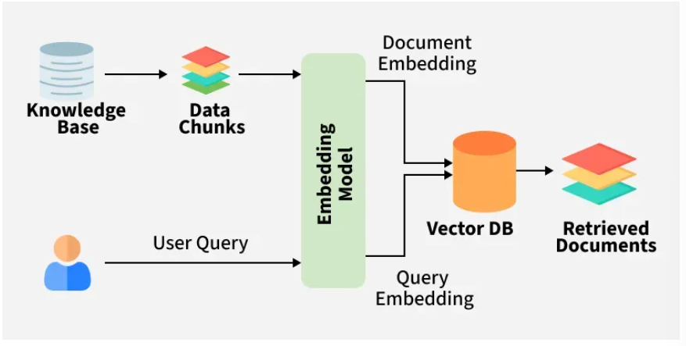
- Creating External Data: External data from APIs, databases or documents is chunked, converted into embeddings and stored in a vector database to build a knowledge library.
- Retrieving Relevant Information: User queries are converted into vectors and matched against stored embeddings to fetch the most relevant data ensuring accurate responses.
- Augmenting the LLM Prompt: Retrieved content is added to the user’s query giving the LLM extra context to work with.
- Answer Generation: LLM uses both the query and retrieved data to generate a factually accurate, context aware response.
- Keeping Data Updated: External data and embeddings are refreshed regularly in real time or scheduled so the system always retrieves latest information.

CHALLENGES

- Complexity: Combining retrieval and generation adds complexity to the model requires careful tuning and optimization to ensure both components work seamlessly together.
- Latency: The retrieval step can introduce latency making it challenging to deploy RAG models in real time applications.
- Quality of Retrieval: The overall performance heavily depends on the quality of the retrieved documents. Poor retrieval can lead to suboptimal generation, undermining the model’s effectiveness.
- Bias and Fairness: It can inherit biases present in the training data or retrieved documents, necessitating ongoing efforts to ensure fairness and mitigate biases.

API integration with Python in RAG

API integration with Python in a Retrieval-Augmented Generation (RAG) system typically happens in two directions: your application acts as an API Client to fetch external data and use Large Language Models (LLMs), and as an API Provider to serve the RAG pipeline to users

1. Integration as an API Client
To build the RAG pipeline, your Python code integrates with multiple external services:
- Data Sources (Retrieval): Instead of just using static PDFs, you can use the Python Requests library to fetch real-time data from REST APIs (e.g., news, weather, or internal company tools) to use as the "retrieved" context.
- LLM Providers: Python scripts use APIs from providers like OpenAI or Google Gemini to send the combined "User Query + Retrieved Context" and receive a generated response.
- Vector Databases: You use client libraries for managed databases (like Pinecone or Azure AI Search) to store and query document embeddings via their respective APIs
2. Integration as an API Provider
To make your RAG system usable by other applications, you wrap the Python logic in a web framework:
- FastAPI: This is the industry standard for creating RAG APIs because it is asynchronous and supports high concurrency.
- Endpoints: You typically define a POST /ask or POST /chat endpoint that takes a user's question, runs the retrieval logic, calls the LLM API, and returns the final answer.
- Orchestration: Tools like LangChain or LlamaIndex help chain these API calls together in a structured "pipeline".

